**8 BEST HOTEL MANAGEMENT SOFTWARE**

1. >
2. [Hospitality Career](https://www.soegjobs.com/category/hospitality-career/)

* Post author:[SOEG JOBS](https://www.soegjobs.com/author/soeg-jobs/)
* Post last modified:August 23, 2021

Given in this article are the top 8 hotel management and reservation software that made it to our list.

Manually updating your hotel information on spreadsheets is a thing of the past. Now hotels, regardless of their sizes, are bringing hotel management software into usage to yield better outputs.

In this post, we have listed the best hotel management software and have explained the need and usefulness of the same.

Automation is the only way forward to stay competitive in most industries. Most of the Hotels and restaurants now use software for most of their administrative purposes. Limited service hotels rely pretty much on automation to ensure cost competitiveness.

There are also several [Amazing Hospitality apps](https://www.soegjobs.com/8-amazing-apps-hospitality-industry/) to help in the effective functioning of hospitality organisations.

Even the Select service Hotels are extremely price-sensitive to ensure they have an edge over Limited service and Full-service hotels.

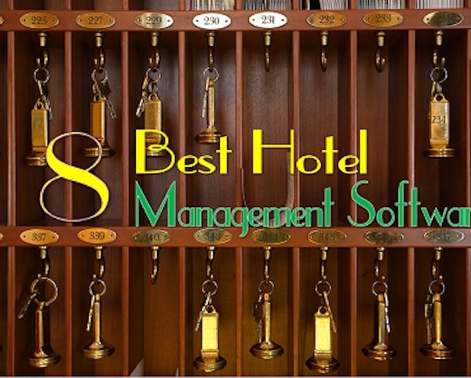8 Best Hotel Management Software

Thus innovative Hotel Management software has a big role to play. If you are looking for competitive advantages in the hotel industry, hospitality management software can help you win big.

You will find numerous hotel property management software in the market, these days. The question which arises here is;

*What makes a hotel management software best in the business?*

The answer to this question varies with a variation in the size of the enterprise we are talking about. For instance, for small hotels, the needs will vary from those of a larger chain of hotels, where more precision and control is required.

The listing below will detail the best Hotel software solutions available to hotels and hospitality establishment in the market.

**1.  eZee Technosys**

eZee Technosys provides a turnkey solution to your hotel management problems.

With a single click, you can manage all the domains of hospitality management, which range from hotel reservations to front desk billing and assistance; laundry services to housekeeping facilities, and many other tasks of the similar sorts.

This is a software management system which has segregated hotel categories for greater ease of clients and end-users.

So lookout for the solutions offered by eZee Technosys as they are frontrunners in delivering awesome hotel management software.

Key hotel management software and [hotel information system solutions](https://www.soegjobs.com/information-systems-used-hotel-industry/) on offer by eZee Technosys are:

* On-Premise Hotel Property Management software-
* Hotel Channel Manager
* Guest Feedback system
* Hotel Booking Engine

Among many others.

**2. My Cloud PMS – Hotel Management Software**

Another top of the charts hotel property management software is [My Cloud PMS](http://www.mycloudhospitality.com/mycloud-pms/). It is a cloud-based system which enables you to exercise all of your hotel management drills in a single go.

We all know the cloud is the future (probably the present while this post is being edited!) and the hospitality industry has already embraced it.

[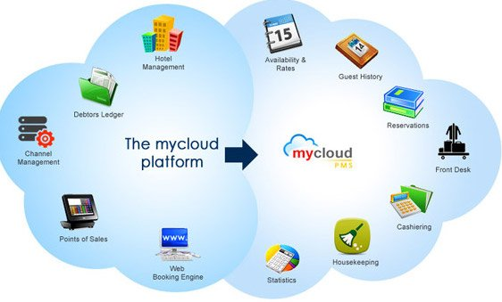](https://www.soegjobs.com/wp-content/uploads/2016/08/mycloud-PMS-best-hotel-management-software.jpg)

Owing to its low asking price and easy to use the system, myCloud PMS is one of the fastest-growing hotel business software providers at the moment.

There are a lot of providers for hotel management software but myCloud PMS is trying to retain the innovative edge within the hospitality industry.

Moreover, round the clock services which require no specific training is what makes it so popular among the users.

And since it is cloud-based you can use it from anywhere.

This excellent hotel management software can be customised according to the needs of the hotel manager and has a lot of features which can be handled at the front end as well.

It is one of the most revolutionary hospitality management software in recent times.

**3.  Skyware Hospitality Solution**

When it comes to property management systems, there isn’t many hotel reservation software which competes with this one.

Apart from its commission-free web reservation services, it offers many other top-rated services.

The online support system connects you to qualified staff members which help you sort out your quarries.

Some of the key innovation in this Hotel property management software are:

* Speed up checkout via mobiles or kiosks
* Visual toolbar and multilingual options in the interface
* Multi-currency option integrated within the software
* Almost all hotel management accounting systems, reports, analyses and software integrated
* Multiple credit card gateways integrated within the system
* Standard benchmarking reports available
* Upgrades ensured to stay up to date with technology

There are a lot of other features in this hotel management software to ensure that hoteliers find it extremely user-friendly and convenient.

**4. Oracle Hospitality**

There are not many names bigger than Oracle in technology and software solutions. Oracle has now a niche in hospitality as it understands the need and demand for hotel management software in the hotel industry.

The hotel management application developed by Oracle helps you improve customer experience by streamlining hotel operations and enhancing the food and beverage maintenance system.

This system is also cloud-based, allowing you authority over your business from anywhere in the world.

There is a lot of innovation on offer and one of the interesting ones is the [Oracle software enabling hotel mobile operations](https://www.oracle.com/industries/hospitality/hotels-resorts/mobile.html). Check on its website the hotel Management software demo that gives the staff of Hotel a seamless range of services from the comfort of the mobile and gives greater autonomy to staff members.

*More importantly, it is a Free Hotel Management Software.*

So why wait? try the free download of this hotel property management software through the Oracle hospitality.

Oracle hospitality also provides software solutions related to foodservice management, hardware solutions and installations as well.

In a nutshell;

*Oracle hospitality is a*one-stop-shop*for all top hotel management software needs*

A few on offer are also Open source software for hotel property management which you can download for a free or one-time nominal charge and customise according to your requirements.

**5.  roomMaster**

Currently, this software is being used in over 100 countries. So, this is a no-brainer as far as reliable hotel management software is concerned.

Due to it’s easy to use interface, regular (free) upgrading technologies, and affordable rates, it is one of the top-quality hospitality property management software.

The live support system helps you interact with professional customer care officers, who are available at your exposure 24/7.

if you ask who can benefit from this extremely affordable hotel management software? Here is a quick list of what is on offer from roomMaster:

* Spa scheduling software
* GDS integration with dynamic rate management and revenue management systems
* Management of hotel rates- removes the hassle of managing rates
* Loyalty cards and membership management
* Restaurant management EPOS software

And a lot of other Hotels related software.

**6.  Hotelogix**

This is one of the top 10 hotel management software providers which is serving hotels from over 100 countries and is one of the most popular ones.

Even better that you can use this hotel property management software free for a trial period of 15 days.

Hotelogix is a multi-dimensional hotel management software firm which encompasses almost all the domains of property management business.

With it, you can manage room reservations, pricing details, housekeeping services, check-ins and check-outs, financial administrations along with many other things.

A well-sung system which offers holistic services to its users all over the world.

Moreover, it is easy to use and requires a minimum amount of training which is why it is so popular in the hotel management business.

**7.  KW Hotel**

A versatile name in the hotel software world, as it is available in three different versions allowing you to operate it any device you want, including your smartphones.

KW Hotel Software is one of the best in business out there for the hospitality industry.

The online reservation system coupled with other services makes it a good choice for your business.

It is easy to use and offers free online assistance making the user experience more worthwhile.

It is one of the very few free hotel management software which further add to its value.

[](https://www.soegjobs.com/wp-content/uploads/2016/08/KWHotel-Mobile-hotel-management-software.jpg)

There are different versions to try from which opens the option for all hospitality properties. There would be no issues scaling should you want to start with the free version.

Also, it has on offer few Open source hotel management software which can be downloaded and then customised around the basic needs.

Free content upgrades and excellent customer services make it one of the best hotel management software.

**8.  Cenium Hospitality**

Cenium Hospitality is also included on our list of best hotel property management software because of its dealings with every area of the hotel business.

May it be the hotel Wifi management software or hotel revenue management software, there is no shortage of options.

It is one of the most power-packed hospitality technology solutions as it popularly quotes;

*The power of one in hotel management software is what this company provides.*

It offers a complete overview of data in real-time which when combined with its mobility and accessibility make it a popular choice among users.

**Conclusion**

Apart from the property management, food and catering services, and administration and financial report makings, there is hotel Wi-Fi management software as well.

These Wifi management software technologies control internet access throughout your building.

Anta-media, My Wi-Fi Service, and Active Prism are a few top-quality system control software which helps you with the purpose.

These types of software for Hotel management given in this article can help you in adapting to the changing trends of the hospitality marketplace.

As a result, you have better control over everything going on in your enterprise.